Thyroid detection

Wireframe Documentation

Thyroid detection

User Interface:

1. The user can view the following web page once entering the web application.

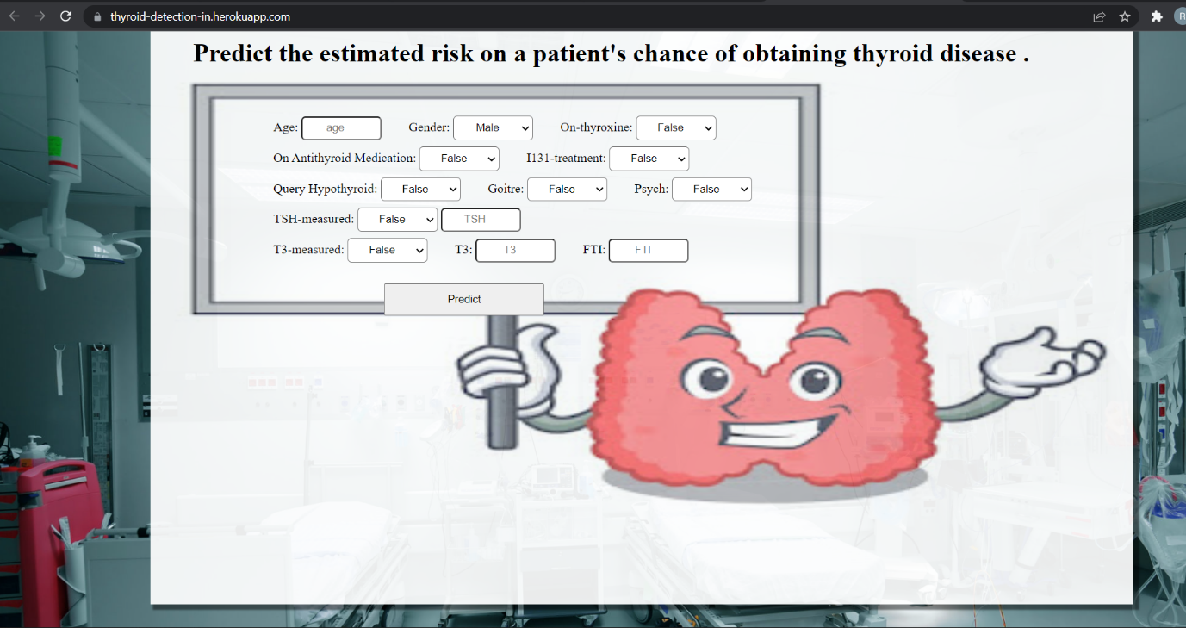

2. Change the values in the fields as needed:



3.After clicking the “Submit ” button, User can see the prediction result on the next page with auto navigation.

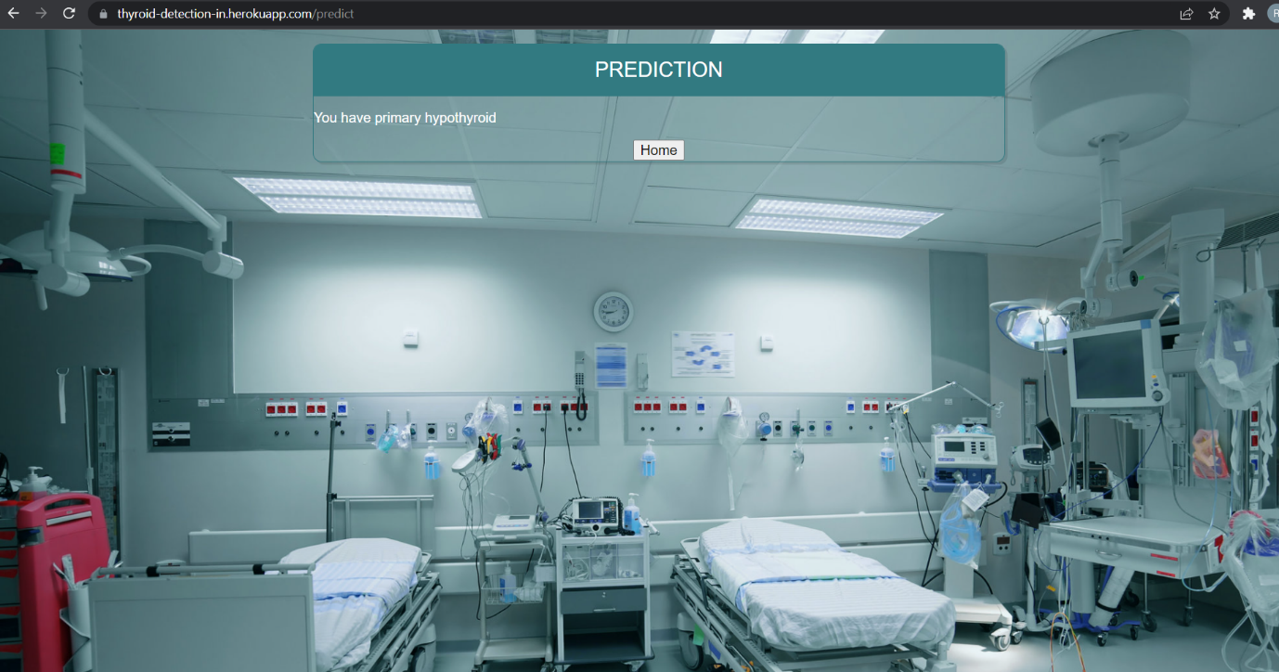

Based on User Inputs, The model will predict the Thyroid and user will get predicted